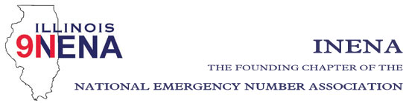

Shelley Dallas
President
(815) 288-5911
sdallas@countyoflee.org

John Ferraro
Vice-President
(847) 590-3407
jferraro@nwcds.org

Stephanie Kroll
Secretary
(815) 814-2999
skroll@dekalbcounty.org

Allan Davis
Treasurer
(618) 664-1911
bond911@sbcglobal.net

REGIONAL DIRECTORS:
Alicia Atkinson, Region 1
(847) 897-7878
aatkinson@redcenter.org

Tiki Schulte, Region 2
(815) 337-7911
tkcarlso@mchenrycountyil.gov

Diana Stiles, Region 3
(815) 879-3803
thedirector@buecomm.com

Amanda Jennings, Region 4
(309) 345-3729
amanda@ci.galesburg.il.us

Phil McCarty, Region 5
(217) 479-4616
pmccarty@jacksonvilleil.gov

Jen Brown, Region 6
(618) 662-7070
911@claycounty.illinois.gov

Cindy Wagner, Region 7
(618) 826-6411
randolph911@yahoo.com

Marty Doyle, Region 8
(773) 405-8103
chizip1@aol.com

Immediate Past President
Vickie DeFord
(217) 452-7187
casscoe911@casscomm.com

General Membership Meeting

Date: October 22, 2023
Time: 4:30 pm
Location: Crowne Plaza, Springfield

- Call to Order Shelley Dallas

- Approval of Prior Minutes: Sept 7, 2023 Shelley Dallas
- Officer Reports
- Opening Comments – year in review Shelley Dallas
- Treasurer Report Allan Davis
Action items: Approval of Treasurer’s Report

- NENA Education Advisory Board – Vicki Pickett
- Committee Reports
a. Legislation – John Ferraro
b. Bylaws – Diana Stiles
d. Education/Training – Alicia Atkinson
e. Awards/Scholarships – Tiki Schulte
f. IL TERT – Heather Butler/LaToya Marz
g. IPSTA – Amanda Jennings-vendors/sponsorship

- Statewide 911 Administrator Report- Cindy Barbera-Brelle

- 2023 Election Results
- Region 8 appointment

- Old Business
- New Business
- Next INENA Meeting – February, 2024 in conjunction with MABAS summit
- Adjournment

