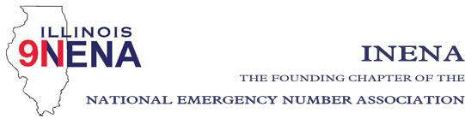

General Membership Meeting
Date: May 5, 2022
Time: 11:00 am
Location: Effingham Event Center
1501 W Fayette Ave., Effingham 62401
• _Call to Order Shelley Dallas

• _Approval of Prior Minutes – February 24, 2022 Shelley Dallas
• _Officer Reports

- Opening Comments Shelley Dallas
- Treasurer Report John Ferraro
Action items: Approval of Treasurer’s Report
• _Regional Director Reports 1-8
• _National Officers Report
• _Committee Reports

a. Legislation – John Ferraro
b. Bylaws – Diana Stiles
c. Website – Diana Stiles/Stephanie Kroll
d. Education/Training – Alicia Atkinson
e. Awards/Scholarships – Tiki Carlson
f. IL TERT – Dale Murray
g. IPSTA – Amanda Jennings-vendors/sponsorship
• _Statewide 911 Administrator Report- Cindy Barbera-Brelle
• _Nominations of Officers begin July 25th for Vice-President, Treasurer, Regions 2, 4, 6, 8

• _Old Business
• _New Business
• _Next INENA Meeting - September 1st, 2022 at 11 am in Plainfield
• _Adjournment

**Lunch will be provided by INdigital following the meetings**

