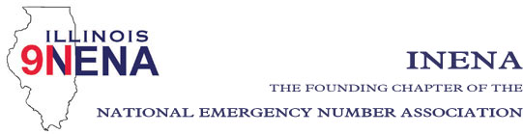

Shelley Dallas
President
(815) 288-5911
sdallas@countyoflee.org

Diana Stiles
Vice President
(815) 879-3803
the.director@buecomm.com

Amber Adams
Secretary
(217) 568-8010
aadams@cirdc.org

John Ferraro
Treasurer
(847) 590-3407
jferraro@nwcds.org

REGION DIRECTORS:
Region 1
Cindy Barbera-Brelle
(217) 782-3200
cindy.barbera-brelle@illinois.gov

Region 2
Theresa Carlson
(815) 337-7911
tkcarlso@mchenrycountyil.gov

Region 3
Jeanine Kaplan
(815) 547-6609
jeaninekaplan.com

Region 4
Amanda Jennings
(309) 345-3729
amanda@ci.galesburg.il.us

Region 5
Phil McCarty
(217) 479-4616
pmccarty@jacksonvilleil.gov

Region 6
Allan Davis
(618) 664-1911
bond911@sbcglobal.net

Region 7
Cindy Wagner
(618) 826-6411
randolph911@yahoo.com

Region 8
Marty Doyle
(312) 743-1322

Immediate Past President
Vicki DeFord
(217) 452-7187
casscoe911@casscomm.com

General Membership Meeting

Date: September 2, 2021
Time: 11:00 am
Location: Plainfield Fire Protection District,
23748 W 135th Street, Plainfield 60544
Training Room A

- Call to Order Shelley Dallas

- Approval of Prior Minutes – July 8, 2021 Shelley Dallas
- Officer Reports
- Opening Comments Shelley Dallas
- Treasurer Report John Ferraro
Action items: Approval of Treasurer’s Report

- Regional Director Reports 1-8
- National Officers Report
- Committee Reports
a. Legislation – defer to IL APCO
b. Education/Training – John Ferraro
c. Awards/Scholarships – Tiki Carlson
d. IL TERT – Latoya Marz

- Statewide 911 Administrator Report- Cindy Barbera-Brelle
- Nominations/Election of Officers - – Vicki DeFord (President, Secretary, Regions 1,3, 5, 7)

- Old Business
- New Business
- Next INENA Meeting - October 24th, 2021 at 4:30 pm at the Crowne Plaza, Springfield
- Adjournment

